NRI Incidents Solutions
Table of contents
I. Delete Provisions | Defective ports in NRI 1
II. Delete the yellow duplicate marked records 4
III. Change Home Status 7

Delete Provisions | Detective ports in NRI
Incident example: INC0383916
For this incident, we get a message containing either deleting provisions or defective ports or sometimes both. Here we’re solving an incident where they’re both in action:
Here are the steps to follow to solve this incident.
- Open the provided sheet attached to the incident
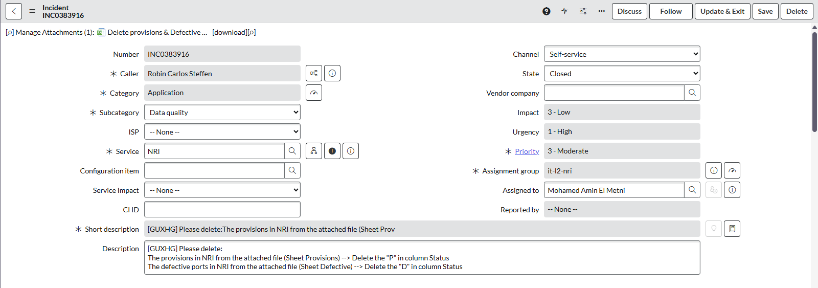Here we can see The Home Ids with provision and the ones with defective ports:
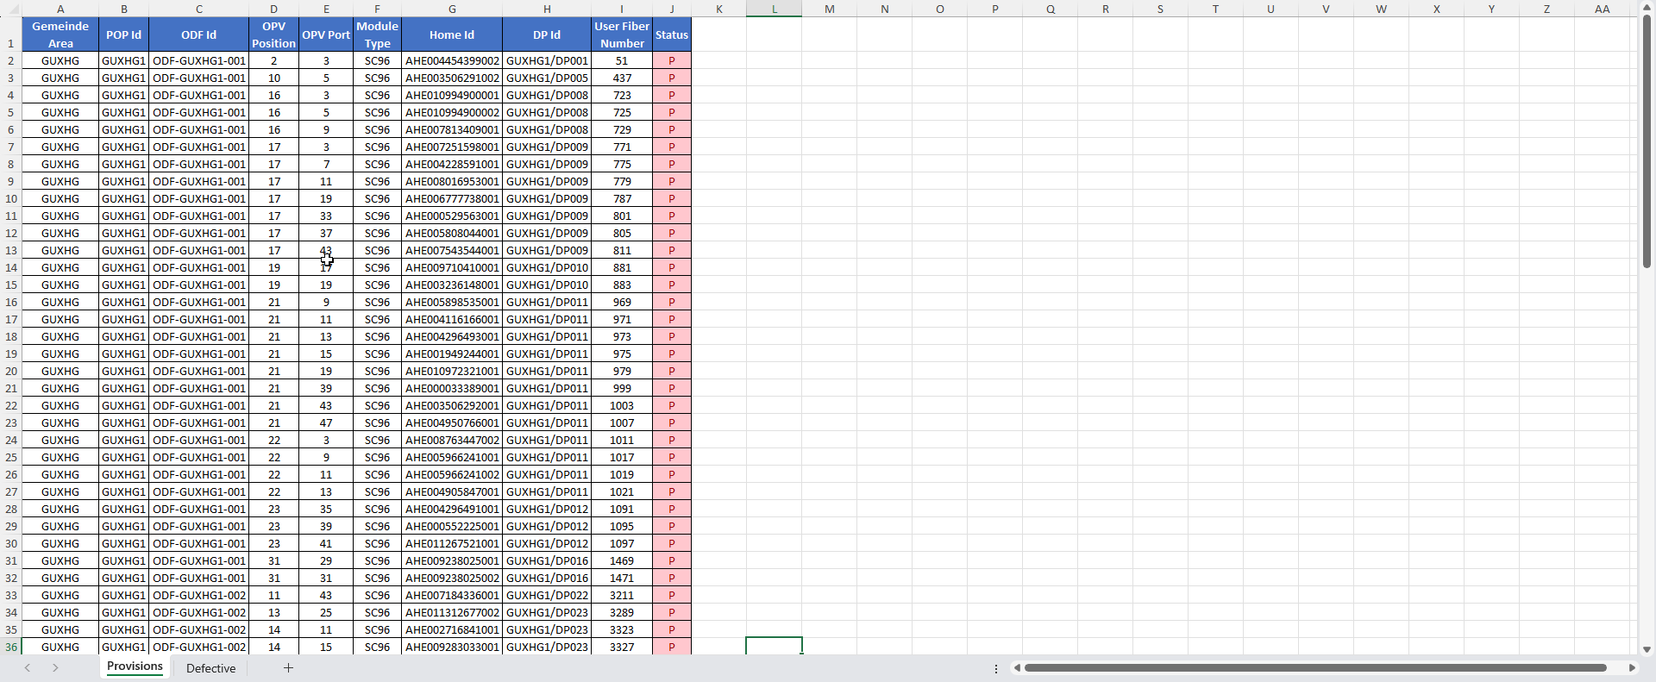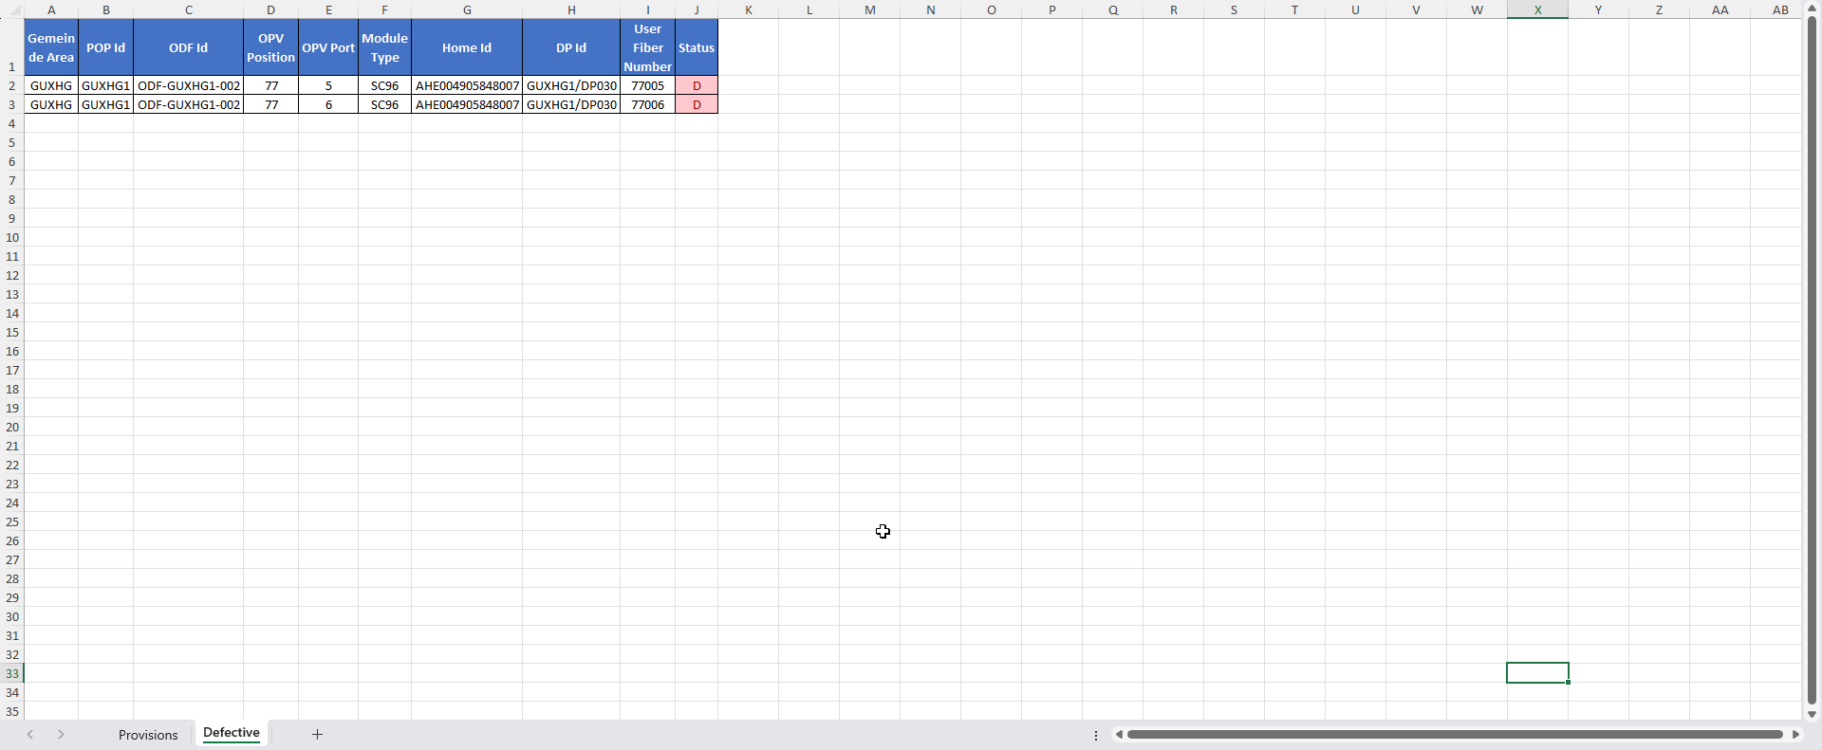
- Open the fm_opv table in the NRI database with DBeaver
Here we can see homes records with homeId, accessNumber and status colums.
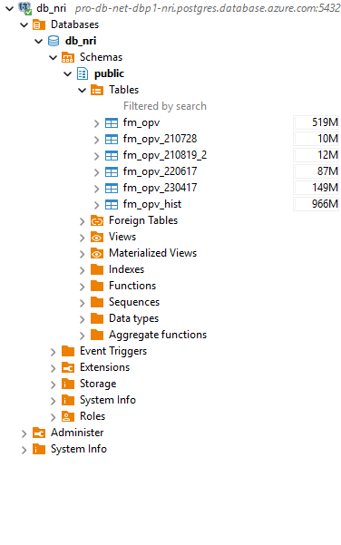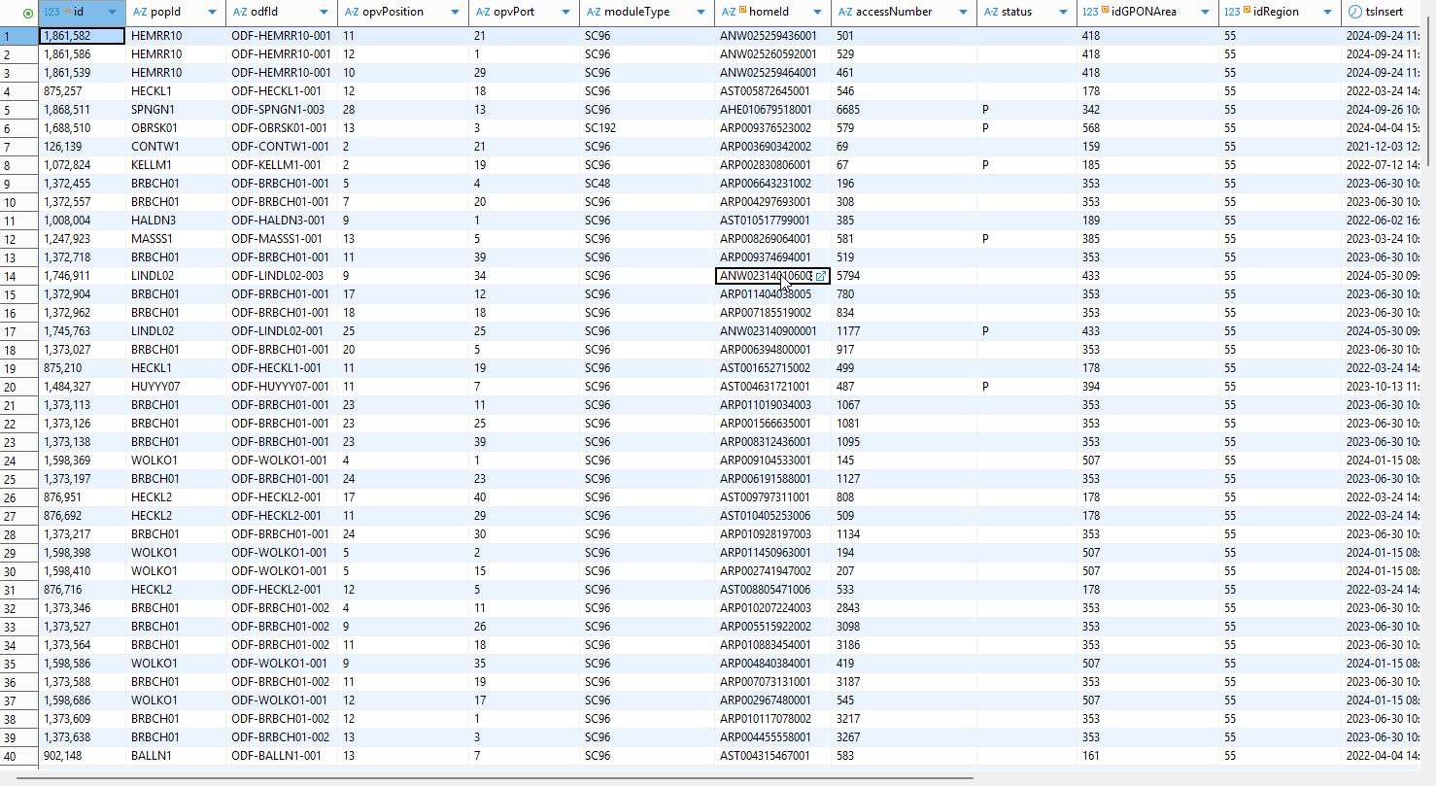
- Update the corresponding records in the fm_opv
Next thing we do is search for homes with homeId and accessNumber provided in the sheet by executing this query in a new SQL script (we add accessNumber in the query to double check that those are the correct homeIds):
select * from fm_opv where "homeId" in ('AHE004454399002','AHE003506291002')
and "accessNumber" in (49,'435');
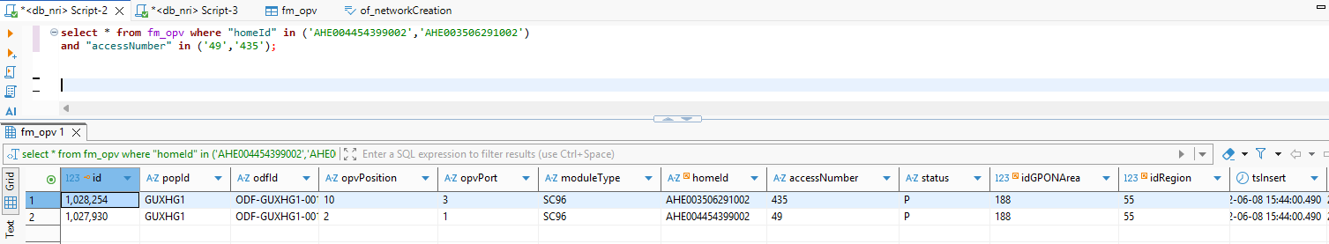We then erase the P if it’s provision or the D if it’s defective port from the status column either manually from the table or by executing this query:
update fm_opv
set "status" = ''
where "homeId" in ('AHE004454399002','AHE003506291002')
and "accessNumber" in (49,'435');
- Update the support_tasks_log table
Finally, we should add records to support_tasks_log table to tell that provision or defective port for the corresponding Home of the corresponding incident was deleted by executing this query after changing the home ids with the ones we have in the sheet and the incident number with the one we have in service now:
insert into support_tasks_log ("homeId",description,"userUpdate")
select aux.homeId,aux.description,0 from (
with tAux(homeId,description) as (values ('AHE004454399002','INC0384100: Provision Deleted'), ('AHE003506291002','INC0384100: Defective Port Deleted'))
select * from tAux
) aux;

- Delete the yellow duplicate marked records
Incident example: INC0384120
For this incident we get a description like the one below alongside with an attachment containing yellow records to be deleted from NRI
What we must do in that case is to delete the mentioned records (the yellow ones) from the fm_opv table in the NRI database.
There two ways to do it:
Method 1:
We can filter the rows by yellow color in the excel file and then filter the update date deleting the records on each certain day, for example we select the yellow records updated in 19/02/2025:
We then select all the list of Home Ids on that day and then execute the function we have in NRI database replacing the first parameter with the home ids we have separating them with a comma and replacing date with:
select public.support_remove_opv_duplicate(‘AHE005853085002,AHE006055585001’, ‘2025-19-02’, 0, true);

In case a home id and update date are duplicated
select public.support_remove_opv_duplicate('ARP002739850001,ARP002739850001', '2024-11-06','2024-11-06', 0, true)

Method 2:
If we encounter an error executing the function (any kind of error) we can always delete the records manually by searching them in the fm_opv table in the NRI database using both the home ids and the access number to make sure we’re deleting the correct records
We can use this query to select the records respecting using the home id with their corresponding access number for each record:
select * from fm_opv where "homeId" in ('AHE004725164002','AHE004725164002')
and "accessNumber" in ('6301','6302');
Then we must save the changes made in the support_tasks_log table in the NRI database adding all the records deleted with this query:
insert into public.support_tasks_log ("homeId", description, "userUpdate") values ('AHE004454399002', 'DELETE OPV DUPLICATED AHE004454399002 tsUpdate = 2025-11-16', 0);

Change Home Status
Incident example: INC0386017
For this incident, the caller asks to change the home status from one to another. We get a description like this one:
Before doing anything, we should make sure caller is from Ugg (we get those incidents mostly from Robin Carlos Steffen) ---- also Martin Rego Gerpe----- if the caller is approved then we should make sure the update is allowed in the matrice
Then we can follow one of 2 methods, the table below showcases the different situations we may encounter:
Home Status From | Home Status To | Method
Any | HomeUnplanned | Method 2
Any | HomePlanningPending | Method 2
HomePlanningPending | HomeUnplanned | Method 1
Any | Any (except HU and HPP) | Method 1
Method 1:
We change the status manually for the provided home ids in the of_networkCreation table in the NRI database by changing the “homeStatus” column value to the correct id. We can see the ids of different status by clicking on the right bottom button on the right panel of DBeaver and then selecting the status cell as shown in the screenshot bellow:
After changing that we must make sure that status is changed in COMA as well, to do that we can first check if the synchronization is on between NRI and COMA in the tmf_resouces table in NRI database by changing the “noded” column value of the corresponding home id (named “name” on that table) from 1 to 0
Then we can check if the status is changed correctly in COMA in the coma_status table in COMA database for those specific homes (it takes some time to be changed 5min -> 30min)
We can accelerate the process if it takes more than usual by changing the home_status column value manually to the corresponding string (but it’s better not to do that in general)
Method 2:
For the second method instead of changing the home status manually in of_networkCreation table, we use a function for that, the function meant to change the status and the delete the OPV resources as well, the function accept 5 parameters, first one the lists of home ids separated with a comma, the second one in the id of the home status we want to change the home to, the third is a Boolean value to say if we delete resources or not in this we set it to true, the fourth is the user making that update we set it to 0 and the last parameter is a Boolean value as well to confirm the change of the status in the of_networkCreation table so we set it to true:
select public."support_changeHomeStatus"('ABW006786126002, ABW006796141065',61, true, 0, true);
Then we can check the synchronization of status between NRI and COMA as well as the status in the COMA system as we did in the first method

